**1.passeneger:**

insert into passenger(p_id,first_name,last_name,nationality,passport_no,booking_id) values(passengersq.nextval,'Ariyan','Saha','Indian','AG8127',100)

insert into passenger(p_id,first_name,last_name,nationality,passport_no,booking_id) values(passengersq.nextval,'Asha','Saha','Bangladeshi','AG8128',101)

insert into passenger(p_id,first_name,last_name,nationality,passport_no,booking_id) values(passengersq.nextval,'Rayhan','Ferdous','Bangladeshi','AG8128',102)

insert into passenger(p_id,first_name,last_name,nationality,passport_no,booking_id) values(passengersq.nextval,'Shakira','Sultana','African','AG8028',103)

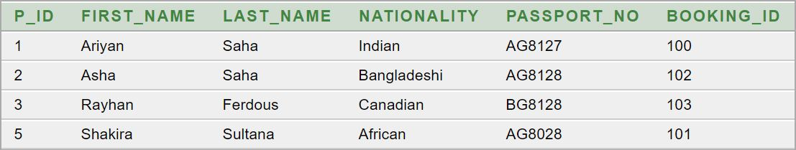

**2.passenger_1:**

insert into passenger_1 values(1,'ariyan@gmail.com')

insert into passenger_1 values(2,'asha@gmail.com')

insert into passenger_1 values(3,'ryhn@gmail.com')

insert into passenger_1 values(5,'shakira@gmail.com')

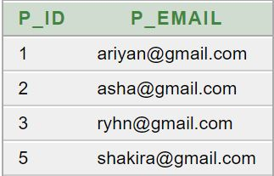

**3.booking:**

insert into booking(booking_id,seat_no,cp_id,flight_no,e_id) values(bookingsq.nextval,20,200,300,700)

insert into booking(booking_id,seat_no,cp_id,flight_no,e_id) values(bookingsq.nextval,21,201,301,701)

insert into booking(booking_id,seat_no,cp_id,flight_no,e_id) values(bookingsq.nextval,30,202,302,702)

insert into booking(booking_id,seat_no,cp_id,flight_no,e_id) values(bookingsq.nextval,35,203,303,703)

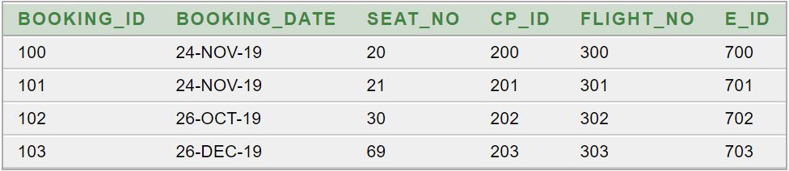

**4.booking_1:**

insert into booking_1(cp_id,class_name,price) values(booking_1sq.nextval,'E.Economy',20000)

insert into booking_1(cp_id,class_name,price) values(booking_1sq.nextval,'Business',24000)

insert into booking_1(cp_id,class_name,price) values(booking_1sq.nextval,'First',30000)

insert into booking_1(cp_id,class_name,price) values(booking_1sq.nextval,'Economy',15000)

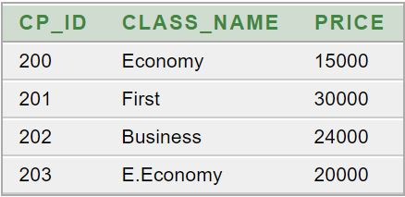

**5.flight:**

insert into flight(flight_no,departure_time,r_id,s_id) values(flightsq.nextval,'8am',400,500)

insert into flight(flight_no,departure_time,r_id,s_id) values(flightsq.nextval,'10pm',401,501)

insert into flight(flight_no,departure_time,r_id,s_id) values(flightsq.nextval,'12pm',402,502)

insert into flight(flight_no,departure_time,r_id,s_id) values(flightsq.nextval,'4am',403,503)

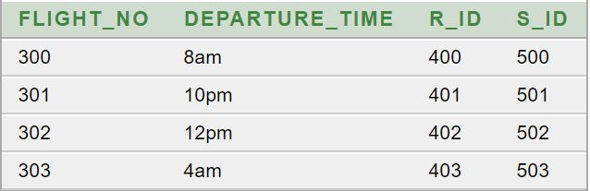

**6.filght_1:**

insert into flight_1(r_id,route,duration) values(flight_1sq.nextval,'Dhaka-Ctg-Kolkata','1H 30M')

insert into flight_1(r_id,route,duration) values(flight_1sq.nextval,'Dhaka-Doha-London','10H 45M')

insert into flight_1(r_id,route,duration) values(flight_1sq.nextval,'Dhaka-Qatar-New York','14H 30M')

insert into flight_1(r_id,route,duration) values(flight_1sq.nextval,'Dubai-India-Bangladesh','5H')

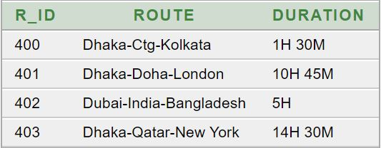

**7.flight_2:**

insert into flight_2(s_id,stoppage_1,stoppage_2,destination) values(flight_2sq.nextval,'Chittagong','Jessore','Kolkata')

insert into flight_2(s_id,stoppage_1,stoppage_2,destination) values(flight_2sq.nextval,'Mumbai','Islamabad','London')

insert into flight_2(s_id,stoppage_1,stoppage_2,destination) values(flight_2sq.nextval,'Nepal','Dheli','Dhaka')

insert into flight_2(s_id,stoppage_1,stoppage_2,destination) values(flight_2sq.nextval,'Spain','Doha','New York')

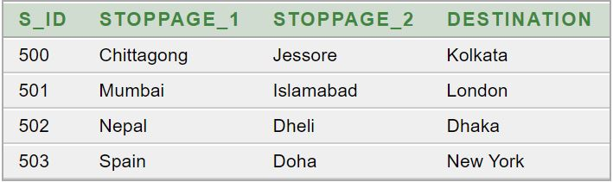

**8.airplane:**

insert into airplane(a_id,type,flight_no) values(airplanesq.nextval,'Boeing 777',300)

insert into airplane(a_id,type,flight_no) values(airplanesq.nextval,'Airbus 701',301)

insert into airplane(a_id,type,flight_no) values(airplanesq.nextval,'Airbus 355',302)

insert into airplane(a_id,type,flight_no) values(airplanesq.nextval,'Airbus 360',303)

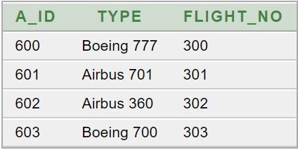

**9.management:**

insert into management(e_id,ef_name,el_name,hiredate,j_id,a_id,ad_id) values(managementsq.nextval,'Mrs.','Shorna','17-DEC-18',801,600,901)

insert into management(e_id,ef_name,el_name,hiredate,j_id,a_id,ad_id) values(managementsq.nextval,'Md.','Sabbir','17-JAN-16',802,601,902)

insert into management(e_id,ef_name,el_name,hiredate,j_id,a_id,ad_id) values(managementsq.nextval,'Andrew','Carlos','17-JAN-16',803,602,903)

insert into management(e_id,ef_name,el_name,hiredate,j_id,a_id,ad_id) values(managementsq.nextval,'Md.','Rasel','14-FEB-15',804,603,904)

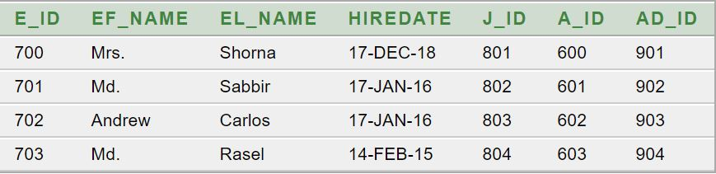

**10.management_1:**

insert into management_1 values(700,01912131427)

insert into management_1 values(700,01912131877)

insert into management_1 values(701,01590186877)

insert into management_1 values(701,01552186877)

insert into management_1 values(701,01590186877)

insert into management_1 values(702,01698186877)

insert into management_1 values(703,01698186844)

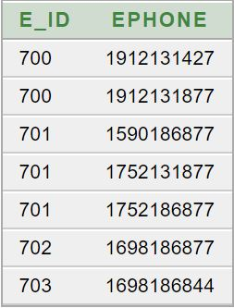

**11.management_2:**

insert into management_2(j_id,salary,job) values(management_2sq.nextval,30000,'Air Hostess')

insert into management_2(j_id,salary,job) values(management_2sq.nextval,40000,'Accountant')

insert into management_2(j_id,salary,job) values(management_2sq.nextval,70000,'Pilot')

insert into management_2(j_id,salary,job) values(management_2sq.nextval,100000,'Manager')

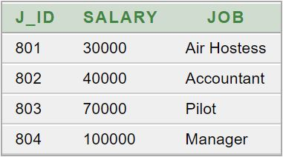

**12.address:**

insert into address(ad_id,street,city,country) values(addresssq.nextval,'Tajmahal Road','Dhaka','Bangladesh')

insert into address(ad_id,street,city) values(addresssq.nextval,'Bailey Road','Dhaka')

insert into address(ad_id,street,city,country) values(addresssq.nextval,'Goerge street','Sydney','Australia')

insert into address(ad_id,street,city,country) values(addresssq.nextval,'Oxford street','London','England')

